Program Flatmästerskap 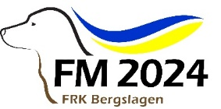
FRK Bergslagen welcomes you to the 2024 Flatcoated Retriever championship on
August 9-11 in Kungsbyn Västerås.

This years championship has 473 entires. In order to pull through this arrangement successfully, you need to carefully read this information and follow it throughout the days of the championship.

Location:
Address: Kungsbyn 33, 72598 Västerås

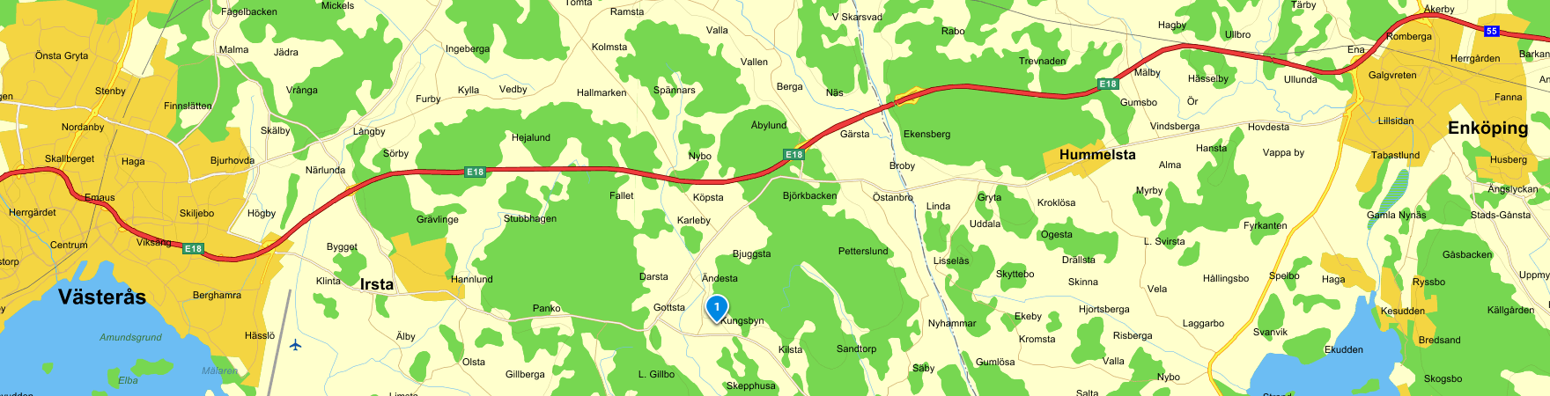

Secretariat is open during the following hours:
Thursday: 14.00 - 21.00
Friday and Saturday: 06.00 - 20.00
Sunday: 07.00 – award ceremony

Entry:
All participants need to report to the secretariat to receive their number tag that is to be carried visible throughout the competition.
Latest at 07.00 on Friday, the following entries need to have reported:
NKL (beginners) loop A Catalog number 001-050
NKL (beginners) loop B Catalog number 106-155
Latest at 10.00 on Friday, the following entries need to have reported:
NKL (beginners) loop A Catalog number 51-105
NKL (beginners) loop B Catalog number 156-209
Latest at 07.00 on Saturday, the following entries need to have reported:
UKL (youngsters) Catalog number 301-350
ÖKL (open) Catalog number 401-450
Latest at 10.00 on Saturday, the following entries need to have reported:
UKL (youth) Catalog number 351-363
ÖKL (open) Catalog number 451-515
Latest at 07.30 on Sunday, all entries to VKL (veteran) and EKL (elit) need to have reported.
Bring the dogs vaccination certificate.
If you are under 26 years old, do not forget to enter for the competition of the best handler under 26 years. This is done in the secretariat when picking up your number tag.
Catalogs can be bought in the secretariat or downloaded from the homepage.
If possible, pick up your number tag the day before to avoid long queues in the morning.

Gathering/information
There will not be any morning gatherings before the competitions starts. You will receive written information regarding starting times, location etc when you report to the secretariat to pick up your number tag.

Opening of competition
On Thursday 8th of August at 6 pm, there will be an official opening of the 2024 flatmästerskap as well as a presentation of the judges. Take the opportunity to pick up your number tag and visit our salesmen at the same time.

Competition
All entries need to pick up their number tag in the secretariat before start.
Shots will occur on every working test station. Only dummies will be used.
Your catalog number is the same as your entry number.
This has been drawn and can be found on bellatezzla.eu/fm2024/start.html

In all classes, everyone starts on working station nr 1 and then follow the rest in numerical order.
Starting order follows the catalog numbers and there is no possibility to change this order on your own, this can only be done with the permission of the championship manager. For those of you entering multiple dogs, we have made the drawn to enable you to enter them all.

It is your responsibility as handler to make sure you are in the right place when it is your turn.
Every working station has a host to give you information about the setup of the station. It is important that you take part of this as you will not receive any information from the judges.
We will make random sample checks of tattoo/chip number on the stations to make sure the correct dog is entered so please bring your dog registration papers with you during the competition.
Lunch and coffee for the judges and helpers will be served on the stations, so please count on short breaks for this.
The championship is performed as a working test with 5 stations in all classes.
- Every station is worth max 20 points.
- Dogs with 0 points on any station can not go on to the finals.
- Dogs with 0 points on any station can not be placed before a dog with points on all stations.
- Points from the five base stations will be brought with to the finals.
- The dogs with the highest points will proceed to the finals in NKL, ÖKL and EKL.
- If two or more dogs have the same score after the finals, the dog with the highest score in the final wins. Following is the dog with the highest amount of 20 points, 19 points etc until separation can be made.
- Judging is made according to SSRK:s rules that we ask you to review before entering (to be found on ssrk.se).

Deletion/change of class
If you can not participate, please report through the link bellatezzla.eu/fm2024/start.html.
If your dog is sick, injured or in heat, the entry fee will be paid back (except an administrative fee of 50 kr) after sending a certificate latest 8 days after the championship to
Ewa Haag, Åbylundsgatan 4C, 70232 Örebro, Sweden or email kassor.bergslagen@frk.nu
To change class based on awards received after entering for this championship, you need to send verification of this to the working test manager on email jakt.bergslagen@frk.nu

Drop out from competition
If you for any reason decide to drop out from the competion, you need to inform the remaining stations hosts of this

Veterinarian
There will be a veterinarian present during the championship. Certification of deworming can be made, bring your own tablets. All contact with the vet is made through the secretariat or on phone number +46-73-5172301.

Protests
Any protests shall be given to the secretariat in writing latest 10 minutes after the class is finished. Cost is 100 SEK which will be repaid if the protest is accepted. It will be handled according to the SSRK:s rules.

Responsibility
FRK Bergslagen as host club and its helpers are not responsible for any injury or loss that can affect any dog or person in connection to this competition. This also applies to any injury or damage caused by any dog during the competition, if it is not proven that it is due to faults/lack in the championship.

Please note!
Help us keep the area tidy and clean.
No garbage in the ground, bring it to the closest garbage sack.
We pick up from our dogs, everywhere!!
Parking is only allowed in marked areas.
No dogs are to be left in the car during hot days!
We reserve the right to smash the car window if there is a dog in a car that is too hot.
No smoking in the grounds due to risk of fire.
As always, bring appropriate clothes.

Food
There will be several food trucks at Kungsbyn to serve food.
There will also be possibility to buy coffee and snacks.

We look forward to a great weekend!

Working test manager: Ewa Haag 070-4875426 jakt.bergslagen@frk.nu
Championship manager: Katarina Morsk 073-5172301 utbildning.bergslagen@frk.nu

Thanks to all our sponsors!
We could not arrange this championship without you.

Thanks to all fantastic helpers for your commitment and hard work during the championship!!!

WELCOME AND GOOD LUCK

